Ibraheem

42896

Bscs 5

Lab 10 :

Lab task 1

Arithmetic task

Screenshot :   
  
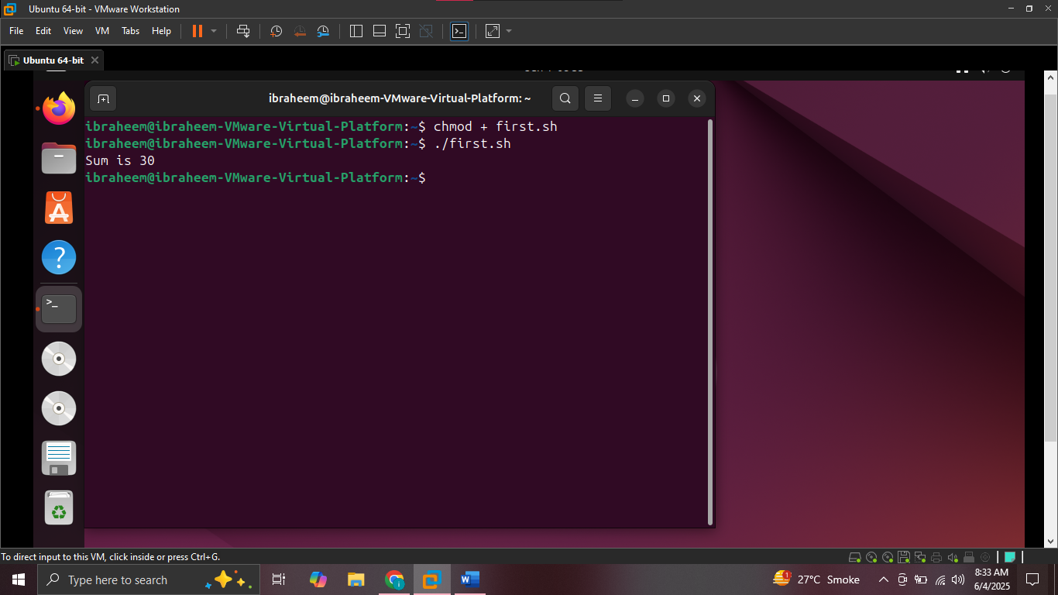

Task 2 :

Comparison operator task

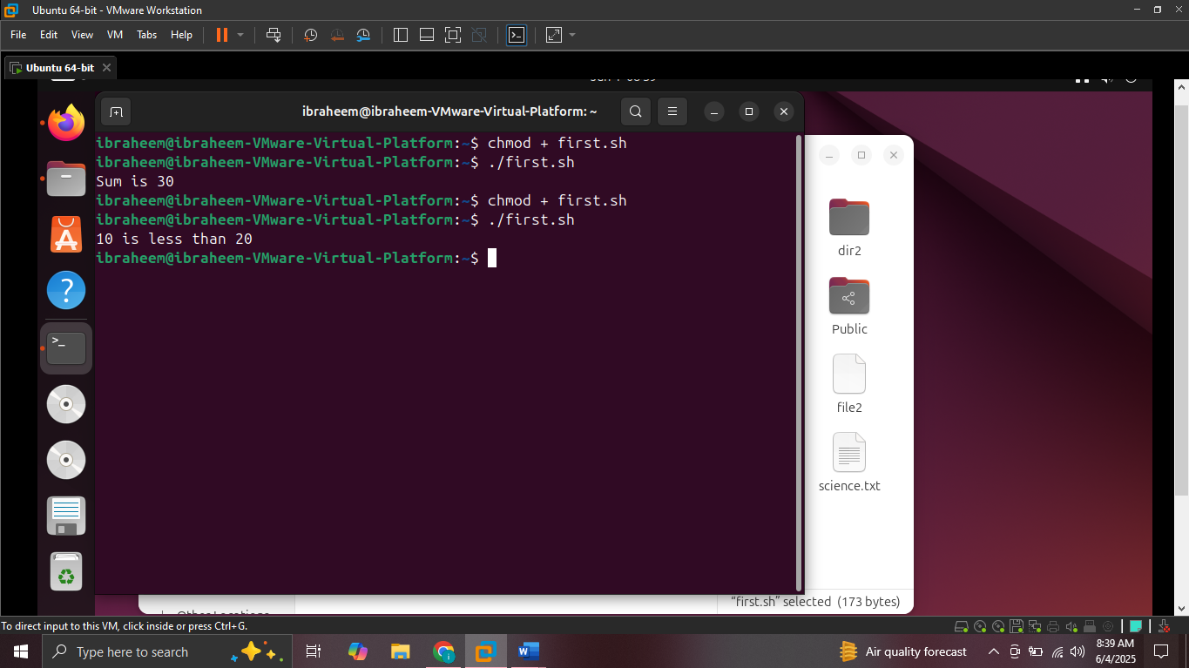

Loop task :

